
https://atlas.cid.harvard.edu/

Optimal Industry Development Strategy Using Economic and Product Complexity

Kenya

─
The Economic Complexity Lab - Columbia University
Alexandra Garcia, Kelly Mi, Margarita Demkina, Allison Lin, Helena Yang, Jane Zhang, Daniel Xu, Ryo Shibata, Navia Zhang, Haoxian Chen, Davepriyan Gunaratnam, Rohan Macherla, Ajit Akole, Shomik Ghose, Alex Wei-Liang Ku, Sannidhya Modi, Xilin Wang
Optimal Industry Development Strategy for Kenya

0. Executive Summary

In this report, we aim to uncover the economic path Kenya went through during the period from 2013 to 2022. Specifically, we dive into the topic through a macroeconomic overview of Kenya from the perspective of Gross Domestic Product (GDP) and Economic Complexity Index (ECI), which reflect countries’ production capability and production structure, respectively. We divide the period into two subperiods: 2013-2018 and 2019-2022. These subperiods are meant to capture differences in pre- and post-pandemic economic progress and resulting optimal development paths. We find that during the period of our interest, Kenya demonstrated a moderate level of economic growth with an average annual GDP growth rate of 6.11% between 2013 and 2018 and 3.16% between 2019 and 2022, with increased economic complexity compared to other major emerging economies.

The mixed progress during the period, we believe, can be partially explained through the analysis of the economic and product complexity structure of Kenya on the industry group level, as well as the stagnant macro and microeconomic strategies. The product classification system we adopt allows us to measure the realized industry development for various industry groups and to observe that Kenya regressed in developing most of its industries during the period while its emerging counterparts and economies around the globe also adopted complex and progressive paths with variable degrees of success.

Based on our analysis of the opportunity gain and sensitivity analysis of major industry groups, Kenya could have furthered its gains by prioritizing Raw Manufacturing and Chemicals in 2018. Four years later, in 2022, its focus should have shifted to the Energy Drilling and Mining and Services and Utilities industries, which are also one of the more developed industries at the time. We further note that Kenya has a slightly mismatched development strategy that indicates a moderate level (compared to other emerging countries) of structural optimality on the complexity level, having an adjusted R-square of around 0.161 in 2018 and a much lower score of 0.012 in 2022, demonstrating improvement in development. Since a significant positive correlation exists between GDP growth and the structural optimality index of an economy as we define and calculate, Kenya indeed has a comparable growth experience as compared with fast-growing economies both on a regional scale and on a global scale and has the potential to further its economic gains through industrial structure optimization as suggested in the paper.

The three years between 2019 and 2022 showed a significant improvement in Kenya's economic growth, boosting its position on the global scale. Its GDP recovered to above the pre-pandemic levels, and it saw a significant boost in the ECI, particularly compared to its peer countries. Its current strategy still has the viable potential upside to increase its performance and optimize its structure further.

1. Report Overview

In this report, we aim to uncover the economic path Kenya went through during the period from 2019 to 2022, before and after the COVID pandemic, compared to its performance from 2013 to 2018, before and after the Standard Gauge Railway infrastructure development project. Specifically, we dive into the topic through a macroeconomic overview of Kenya from the perspective of Gross Domestic Product (GDP) and Economic Complexity Index (ECI), which reflect countries’ production capability and production structure, respectively. We then analyze the industrial framework and changes of Kenya during the period based on quantitative measures such as the Product Complexity Index (PCI) and Product Family Complexity Index (PfCI), followed by a detailed analysis of how such changes have matched with development strategies as quantitatively measured by opportunity gains on an industry-level. We conclude our report with macro-level results and predictions of Kenya, as deduced from regression models we have established on a global scale, which take into account countries’ stances in their product space.

2. Macroeconomic Results

2.1 GDP Ranking and Changes
Figure 1a illustrates the time-series GDP results for Kenya and three its peer countries (United Republic of Tanzania, Ethiopia, and Ghana) from 2013 to 2018. Similar to the other countries, Kenya displayed an eventual upward trend over the period; however, its growth was less consistent than Ethiopia. Kenya’s average annual GDP growth rate (6.11%) was the greater than Ghana’s rate (5.26%) but less than Ethiopia’s rate (9.34%).

Figure 1b shows the GDP levels for Kenya and its peer countries (Nigeria, Ethiopia, and Togo) from 2019 to 2022. Similar to the other countries, Kenya displayed no increase in GDP from 2019 to 2020 because of the pandemic, with all GDPs rebounding in 2022. Over these three years, Kenya’s average annual GDP growth rate (3.16%) is moderate, as it is greater than Nigeria’s rate (0.34%) but less than Ethiopia’s (7.39%) and Togo’s rates (3.99%). It is notable that the GDP levels in Kenya and Togo almost evened out after 2018.

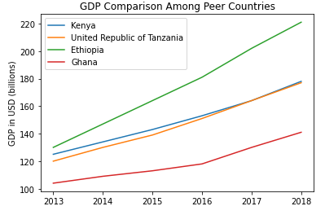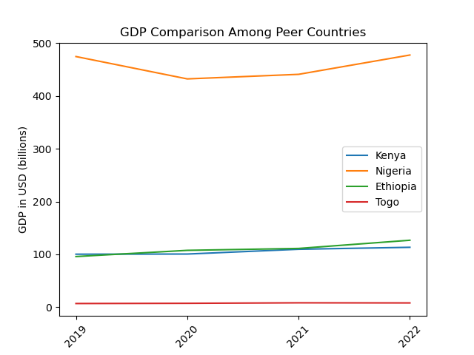
Figures 1a and 1b. GDP Comparison Among Peer Countries (left: 2013-2018; right: 2019-2022)

2.2 ECI Ranking and Changes
The Economic Complexity Index (ECI), as defined by Ricardo Hausmann and Cesar Hidalgo in 2009 to explain the knowledge accumulated in a country's population, is illustrated in Figures 2a and 2b.

As shown, Kenya exhibits a decrease in production capability from 2013 to 2018. Kenya is in a weak position in ECI terms, as its ECI change of -589% is greater than that of Tanzania (125.97%), Ethiopia (23.45%), and Ghana (-46.21%).

The comparable countries experience large changes in ECI between 2019 and 2022. Kenya exhibits strong increase in production capability in 2022 compared to previous levels, with the pandemic being one of the reasons. Kenya has seen a 439.22% increase in its ECI, which is greater than Nigeria's (55.39%), Ethiopia's (204.55%), and Togo's (205.18%).

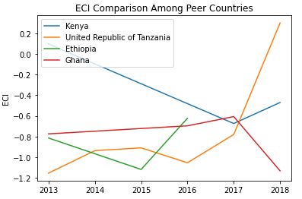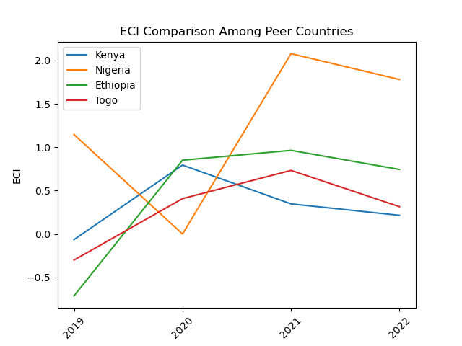
Figures 2a and 2b. ECI Comparison Among Peer Countries (left: 2013-2018; right: 2019-2022)

Figures 3a and 3b offer a further comparison of GDP Growth and ECI over the time span from 2013 to 2022 for Kenya. The results show that the economic growth experienced by Kenya during the period from 2013 to 2018 is only partially consistentwith the predictions by ECI and that Kenya made weak progress towards effectively developing a competitive product space that helps to accumulate complicated knowledge and technology. For the period 2019 to 2022, the ECI followed GDP trends, which can be interpreted as advancements in production. In order to provide a more concrete answer to why this has happened, we will dive into an analysis of Kenya’s production structure and its product space designs in the next few sections.

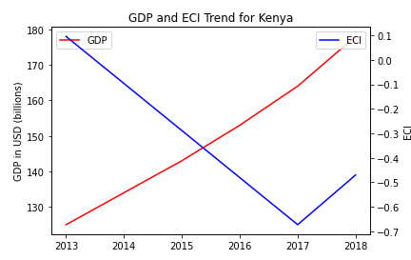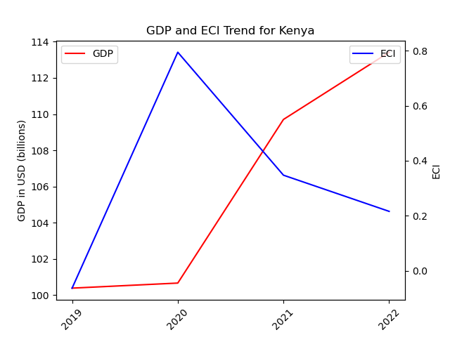
Figures 3a and 3b. GDP Growth and ECI for Kenya (left: 2013-2018; right: 2019-2022)

3. Production Analysis

3.1 Product Categorization
Our main data source in this research is the UN Comtrade Website (https://comtrade.un.org), which provides us with valuable information on countries’ export values on an annual basis, including highly specific export data for more than 5000 categories of products. In order to have a holistic vision of the product space of a country, however, a level of categorization is required. Products in our data source are labeled from 010000-999999, with the first two digits representing a general category to which the product belongs. Based on the 99 categories extracted from the label, we further group the products into the 18 most widely-accepted industries, as summarized in Table 1.

Note that the High-complexity Products industry group is not a distinct industry but rather an aggregated industry that encompasses the most complicated products from the most technologically-advanced industries (as measured by PCI). This industry serves as an indicator for us to quantitatively evaluate how well a country has performed in developing cutting-edge technologies and closing its technological gap with advanced economies, which has become a topic of wide concern today. Indeed, when we rank the 18 categories based on PfCI (an equivalent concept of PCI as calculated based on the 18 categorized product groups), the High-complexity Products industry has the highest PfCI among all industry groups.

Category | Description
Animals and By-products | All kinds of meat, livestock and related by-products
Vegetables, Fruits and Plants | All kinds of plants, edible vegetables and fruits
Food and Preparations | Edible preparations, raw cooking materials and appliances
Clothing and Accessories | All kinds of fabrics, filament, clothing and accessories
Textiles | All kinds of textile articles and related products
Wood Products | Book, paper and other elementary products related to wood
Metals | Mining of all sorts of raw Metals
Refined and Processed Stones | Refined or processed stone products such as pearl and ceramics
Energy Drilling and Mining | Mining industry for energy, minerals, stone materials, etc.
Daily Instruments | Basic daily instruments such as sport requisites, timing and measuring tools
Raw Manufacturing | Basic products made from plastic, rubber, leather, etc.
Chemical Manufacturing | Advanced chemical products and pharmaceutical products
Chemicals | Raw chemical materials and by-products
Machinery and Construction | Machinery and mechanical appliances, including electrical equipment
Transportation | Vehicles and locomotives including aircraft, ship, railway, etc.
Weapons | Explosives, arms and ammunition
Services and Utilities | Financial, business, legal, communication, travel Services and Utilities, etc.
High-complexity Products | Agglomeration of advanced products with highest PCIs
Table 1. Categorization of Products

We further observe a positive correlation between the GDP and the export of High-complexity Products. A higher adjusted R-square exists between GDP and High-complexity Products exports, indicating that more successful economics, as measured by GDP, tend to be those that are capable of producing and exporting High-complexity Products as we define them. Tables 2a and 2b show the OLS results in a universe of 107 and 21 typical countries respectively.

 | High-complexity Products | Food and Preparations | Animals and By-products
Adj. R-squared | 0.075 | 0.006 | 0.002
F-statistic | 9.556 | 1.638 | 1.175
No. Observations | 107 | 107 | 107
Table 2a. OLS Regression Results of GDP against Percentage Volume of Exports

 | High-complexity Products | Food and Preparations | Animals and By-products
Adj. R-squared | 0.149 | 0.003 | -0.012
F-statistic | 4.510 | 1.059 | 0.7542
No. Observations | 21 | 21 | 21
Table 2b. OLS Regression Results of GDP against Volume of Percentage Exports

3.2 Realized Industry Development
Based on the aforementioned product categorization, we aim to capture Kenya's realized industry production strategy between 2013 and 2022 on a complexity level. In Hausmann and Hidalgo (2009), distance is defined to be a measure of how far a country is from a certain product, not in its product space. We extend this concept to all product groups and quantify how technically equipped a country is to develop the corresponding product groups. In other words, the shorter the distance between a country and a product group, the more capable a country is of developing products within that group. Defining this net distance change as the Realized Industry Development (RID), our export data allow us to calculate and compare the RID of Kenya and the 18 product groups in 2022 and 2018 through the difference, where a positive RID indicates a shortening of the distance (i.e., advancement of the industry), and a negative RID indicates the reverse. It is notable that the number of industries with positive RID has decreased from 18 to 16 from 2018 to 2022.

Category | RID (2022) | RID (2018)
Daily Instruments | 0.048779 | 0.156140
Chemicals | 0.003745 | 0.055092
Weapons | 0.023343 | 0.103975
Wood Products | 0.025610 | 0.041813
Transportation | 0.040256 | 0.178194
Machinery and Construction | 0.039431 | 0.161162
Metals | 0.032109 | 0.067617
Raw Manufacturing | 0.043331 | 0.068784
Services and Utilities | 0.072982 | 0.159376
Clothing and Accessories | 0.03781 | 0.084328
Chemical Manufacturing | -0.02198 | 0.188701
Food and Preparations | 0.035510 | 0.105444
Textile | -0.006900 | 0.03259
High-complexity Products | 0.084101 | 0.161805
Vegetables, Fruits and Plants | 0.016037 | 0.068633
Animals and By-products | 0.044215 | 0.045799
Energy Drilling and Mining | 0.067200 | 0.183877
Precious Stones | 0.026166 | 0.079446
Table 3. Realized Industry Development (RID) of Kenya
3.3 Regional and Global Comparison
Tables 4a-4b below summarize how the production strategy adopted by Kenya compares with selected leading economies in the world across different years, as measured in RID. Leading economies such as France, the US, and Germany gave a considerable level of attention to more advanced product groups such as High-complexity Products in 2018 and Transportation and High-complexity Products in 2022.

Ranking | France | US | Germany
1 | High-complexity Products | Services and Utilities | High-complexity Products
2 | Chemical Manufacturing | Weapons | Transportation
3 | Daily Instruments | Raw Manufacturing | Wood Products
4 | Animals and By-products | Precious Stones | Metals
5 | Food and Preparations | Animals and By-products | Food and Preparations
Table 4a. RID Comparison across Leading Economies (2018)

Ranking | France | Canada | Sweden
1 | Services and Utilities | Energy Drilling and Mining | High-complexity Products
2 | High-complexity Products | Animals and By-products | Transportation
3 | Precious Stones | Vegetables, Fruits and Plants | Precious Stones
4 | Transportation | High-complexity Products | Chemical Manufacturing
5 | Energy Drilling and Mining | Wood Products | Chemicals
Table 4b. RID Comparison across Leading Economies (2022)

Tables 4c-4d further examine Kenya's development strategy against those of emerging economies on a global scale. Reasonably, emerging economies such as China, South Korea, and Singapore have devoted the majority of their efforts to intermediate industry groups, showing significant shifts in strategies over the course of three years.

Ranking | China | South Korea | Singapore
1 | High-complexity Products | Transportation | Transportation
2 | Transportation | Textile | High-complexity Products
3 | Machinery and Construction | High-complexity Products | Precious Stones
4 | Energy Drilling and Mining | Chemical Manufacturing | Daily Instruments
5 | Daily Instruments | Machinery and Construction | Services and Utilities
Table 4c. RID Comparison across Emerging Economies (2018)

Ranking | China | South Korea | Singapore
1 | Daily Instruments | Chemicals | Transportation
2 | Chemicals | Daily Instruments | Weapons
3 | Raw Manufacturing | Metals | High-complexity Products
4 | Metals | Raw Manufacturing | Energy Drilling and Mining
5 | Machinery and Construction | Chemical Manufacturing | Machinery
Table 4d. RID Comparison across Emerging Economies (2022)

4. Product Space Design

4.1 Suggested Development Vector
As outlined above, distance gives us an idea of how far each new product is from a country’s current mix of exports. As defined in Hausmann and Hidalgo (2009), distance is “the weighted proportion of products connected to goods p that country c is not exporting, i.e., MCP = 0.” Based on this definition, the distance between a country and any product that the country is currently exporting (i.e., the country is a significant exporter of the product as compared to the global average) is zero. Similarly, opportunity gain quantifies the contribution of a new product in terms of opening up the doors to more and more complex products. Intuitively, a product that a country is currently exporting (i.e., MCP = 1) has an opportunity gain of zero. An unreasonable investment in a certain product p would lead to a relative decrement in the export of more profitable products and therefore lead to a negative opportunity gain of product p. The opportunity gain is not the only estimator of a country’s level of economic development. However, among countries with comparable economic strength, those having higher ECI, or in other words, more reasonable economic structures are often in better shape.

Rank | Kenya | Spain | Greece
1 | Energy Drilling and Mining | Energy Drilling and Mining | Precious Stones
2 | Precious Stones | Precious Stones | Weapons
3 | Animals and By-products | Weapons | Clothing and Accessories
4 | Machinery and Construction | Textile | Machinery and Construction
5 | High-complexity Products | Chemicals | Services and Utilities
6 | Services and Utilities | Daily Instruments | High-complexity Products
7 | Transportation | Animals and By-products | Daily Instruments
8 | Weapons | Vegetables, Fruits and Plants | Transportation
9 | Daily Instruments | Food and Preparations | Chemicals
10 | Textile | Chemical Manufacturing | Animals and By-products
11 | Vegetables, Fruits and Plants | Raw Manufacturing | Vegetables, Fruits, and Plants
12 | Food and Preparations | Wood Products | Food and Preparations
13 | Chemicals | Clothing and Accessories | Energy Drilling and Mining
14 | Chemical Manufacturing | Metals | Chemical Manufacturing
15 | Raw Manufacturing | Transportation | Raw Manufacturing
16 | Wood Products | Services and Utilities | Wood Products
17 | Clothing and Accessories | Machinery and Construction | Textile
18 | Metals | High-complexity Products | Metals
ECI | 0.096149424 | 0.45830144 | -0.232930358
Table 5a. Opportunity Gain Ranking on a Comparable Scale (2013)

Rank | Kenya | Spain | Greece
1 | Transportation | Energy Drilling and Mining | Precious Stones
2 | High-complexity Products | Precious Stones | Clothing and Accessories
3 | Machinery and Construction | Weapons | High-complexity Products
4 | Animals and By-products | Textile | Transportation
5 | Precious Stones | Services and Utilities | Machinery and Construction
6 | Metals | Chemicals | Weapons
7 | Services and Utilities | Daily Instruments | Chemicals
8 | Daily Instruments | Machinery and Construction | Services and Utilities
9 | Textile | Animals and By-products | Daily Instruments
10 | Chemicals | Vegetables, Fruits and Plants | Animals and By-products
11 | Raw Manufacturing | Food and Preparations | Vegetables, Fruits and Plants
12 | Vegetables, Fruits and Plants | Chemical Manufacturing | Food and Preparations
13 | Food and Preparations | Raw Manufacturing | Energy Drilling and Mining
14 | Energy Drilling and Mining | Wood Products | Chemical Manufacturing
15 | Chemical Manufacturing | Clothing and Accessories | Raw Manufacturing
16 | Wood Products | Metals | Wood Products
17 | Clothing and Accessories | Transportation | Textile
18 | Weapons | High-complexity Products | Metals
ECI | -0.470227099 | 0.168962035 | -0.425579783
Table 5b. Opportunity Gain Ranking on a Comparable Scale (2018)

Rank | Kenya | Colombia | Nigeria
1 | Energy Drilling and Mining | High-complexity Products | High-complexity Products
2 | Services and Utilities | Services and Utilities | Services and Utilities
3 | Precious Stones | Transportation | Transportation
4 | High-complexity Products | Daily Instruments | Daily Instruments
5 | Chemicals | Machinery and Construction | Chemical Manufacturing
6 | Chemical Manufacturing | Chemical Manufacturing | Machinery and Construction
7 | Raw Manufacturing | Chemicals | Chemicals
8 | Daily Instruments | Weapons | Weapons
9 | Transportation | Animals and By-products | Raw Manufacturing
10 | Metals | Raw Manufacturing | Energy Drilling and Mining
11 | Animals and By-products | Metals | Metals
12 | Vegetables, Fruits and Plants | Wood Products | Wood Products
13 | Food and Preparations | Clothing and Accessories | Clothing and Accessories
14 | Wood Products | Textile | Precious Stones
15 | Clothing and Accessories | Vegetables, Fruits and Plants | Animals and By-products
16 | Textile | Food and Preparations | Food and Preparations
17 | Machinery and Construction | Energy Drilling and Mining | Textile
18 | Weapons | Precious Stones | Vegetables, Fruits and Plants
ECI | 0.347338 | 1.058294 | 2.469797
Table 5c. Opportunity Gain Ranking on a Comparable Scale (2022)

We define the ranking of opportunity gain for a country c, as the Suggested Development Vector (SDV) of c. Tables 5a-5c summarize how the SDV of Kenya compares with a selected group of comparable and leading economies in the world, with the industry groups ranked in decreasing order of significance.

Dark blue indicates positive opportunity gains, light blue indicates zero opportunity gains, and white indicates negative opportunity gains. The result shows that leading countries barely have any industries with positive opportunity gain. In other words, those countries are already in the most stable and efficient economic structure. Without the necessity of economic transition, those countries merely need to maintain a steady and balanced economic development. In contrast, developing countries have nearly half of industries with positive opportunity gain and share common interests in Chemicals and Chemical Manufacturing industries. It can be concluded that Kenya shares the characteristics of developing countries, with a balanced economic structure that leans towards manufacturing-level industries.
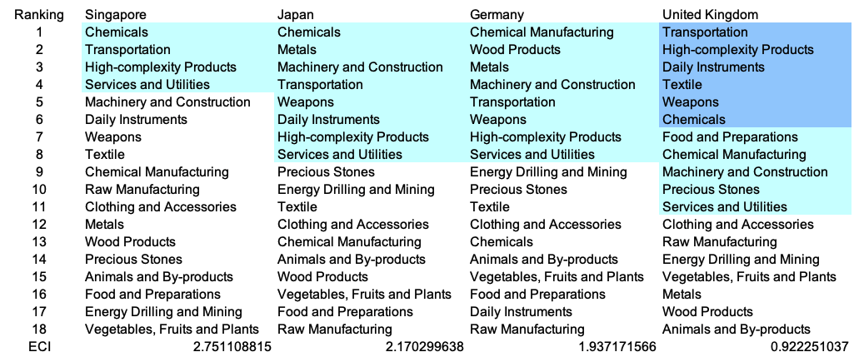Table 6. SDV of Other Sample Countries (2013)

4.2 Budgeted Industry Development Strategy and Interpretation
The optimal budgeted industry development strategy aims to solve the most efficient allocations under the budgeted constraint of different situations of heuristic total export growth. In order to obtain such an allocation portfolio, we formulate an optimization problem as the following:



where k(x) is the second largest eigenvector of $M_{CC'}$ after adding $x$ to the original export vector, C is the country that we are interested in, P is the product space, B is the heuristic budget.

If we can solve this problem, then we can know what the largest ECI to which a country can improve. Accordingly, the optimal solution $x*$ that we obtain here is exactly our optimal allocation. However, the biggest problem is that the objective function is not convex. Therefore, we cannot apply the classical tools for convex optimization to this problem. In order to solve this problem, our idea is to use a greedy algorithm. The way that we apply the greedy algorithm is that firstly we separate the total budget into k equal parts, and then for the first equal part we try to search for the product that can optimize our objective function by iterating through each $p∈P$. After we find the optimal product p for this equal part, we add the amount back to the export value of this product p and update the ECI for this country. If we observe that ECI does not change after iterating all the products, then we can add up one more equal part to invest. Until we find there is an ECI increment, we add the amount now to that product. The equal rest parts can be done in the same way.

By definition, a greedy algorithm is a kind of local search algorithm that is possible to run into a local minimum. Therefore, for local search algorithms, one typical way to keep it away from the local minimum is to enhance the vision of the algorithm by looking more steps forward. In our setting, whenever we obtain an increment of ECI, we mark down the required amount of export growth. Simultaneously, we continue searching for the next ECI increment point, compare the ratios of these two possibilities and pick the largest one. The ratio is defined as the following:

where ${ECI}_{p}$ is just the ECI of the country after adding some amount of export increment to product $p$, which is exactly the amount that is able to make ECI change. Also, we can express it in the way of $||$$x_{p}-x_{0}$${||}_{1}$.

In this way, we can obtain a further sighted greedy algorithm. Also, the number of parts that we would like to separate the budget into also matters. In order to solve this problem, we added a stabilizer on top of the enhanced greedy algorithm by running the algorithm for different numbers of parts and selecting the portfolio with the largest ECI increment and most complex economic structure.

Besides, it is quite common that there is a surplus in the budget. To deal with the surplus, we just add it to the product which needs the least amount of dollars to make $M_{cp}$ = 1 (i.e., the smallest amount of required export increase).

Economic Panel
As stated above, the enhanced greedy algorithm is developed mainly for solving the optimal allocation strategy. In order to visualize this allocation, an economic panel is created, consisting of a pie chart, a line chart and a table. First, a pie chart is used to show the percentage of each product in the optimal portfolio. The number located in the center of the circle denotes the heuristic growth of total export, which is also our budget. Each category in the chart has a determined percentage of the allocated budget. The lines below the pie charts show how the ECI changes during the searching process of the greedy algorithm. Even though sometimes an increase of the export by 15% or 20% does not seem reasonable to developed countries, yet it can also give a sense of how a country should develop in the long term. Eventually, the graph in the end is just for numerical explanation for the pie charts.

Interpretation
For the purpose of a clear explanation of the line charts, we label all the products in Table 7. Please refer to this table when trying to understand the investment trajectories in the line charts.

Label | Product Names
1 | Animal and By-products
2 | Vegetables, Fruits and Plants
3 | Food and Preparations
4 | Energy Drilling and Mining
5 | Chemicals
6 | Chemical Manufacturing
7 | Raw Manufacturing
8 | Wood Products
9 | Clothing and Accessories
10 | Textile
11 | Metals
12 | Machinery and Construction
13 | Transportation
14 | Weapons
15 | Daily Instruments
16 | Precious Stones
17 | High-complexity Products
18 | Services and Utilities
Table 7. Products Labeling

Figures 4a-4c show an economic panel for Kenya in 2013, 2018, and 2022. We can see that for different percentages of heuristic total export growth, the ECIs of Kenya actually have different increments.

Below is the economic panel for Kenya in 2013. We can see that for different percentages of heuristic total export growth, the ECIs of Kenya actually have different amounts of increments. Overall, a 5 percent export growth results in an ECI improvement pattern starting from around 0.10 and endings at around 0.36. As the budget is increased to 10 percent export growth, the ECI of Kenya can achieve a slightly higher level, which is around 0.47. With a much larger growth budget, including 15 and 20 percent growth, Kenya is able to achieve an even much higher stage, which is around 0.72.

For the case of 5 percent export growth, Animals and By-products, Services and Utilities, and Textiles account for most of the portfolio. For 10 percent export growth, the portfolio becomes more diverse. In addition to the products mentioned before, Daily Instruments are added as one of the main components as well. For the cases of 15 and 20 percent growth budgets, the solved portfolios are even more comprehensive. Not only do they follow similar ECI improvement trajectories, but they also share a pretty close investment portfolio, which are mainly made up of Machinery and Construction, Animals and By-products, and Services and Utilities, etc. In these four ECI improvement trajectories, we also notice that the largest improvement comes from Services and Utilities and Textiles, suggesting that with a low economic improvement anticipation, Kenya should focus more on developing these products. A more detailed numerical representation of the portfolio is shown in Table 8.
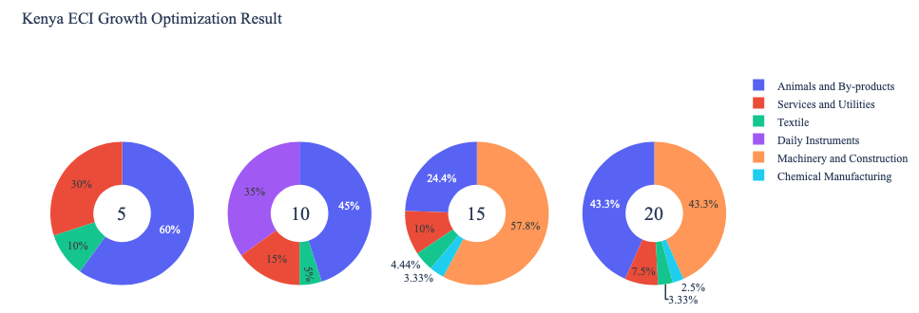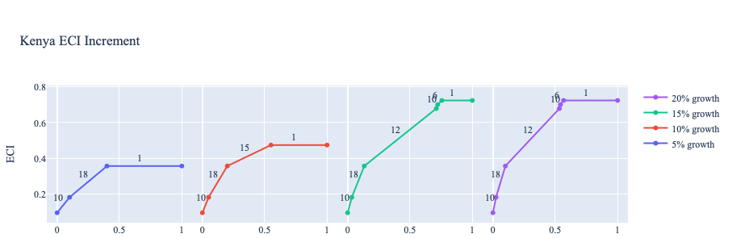

Figure 4a. Greedy-Based ECI Improvement Results of Kenya with Different Budgets (2013)

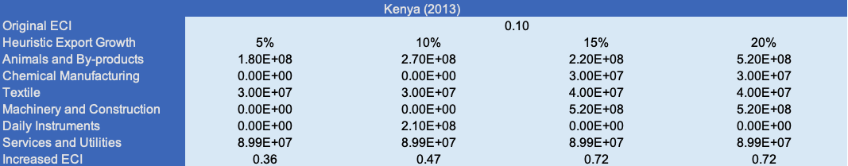
Table 8a. Portfolio of Kenya (2013)

For further suggestions on Kenya’s development in the future, we also offer the optimization result based on its export data in 2018. Below is the economic panel for Kenya in 2018. We can see that as the growth budget increases, a higher ECI can be achieved. With 5 percent export growth, the main components in the portfolio include Animals and By-products, Rraw manufacturing, Chemical Manufacturing and Textiles. For the case of 10 percent growth, in addition to the components mentioned before, chemicals and daily instruments serve as another two important factors. Additionally, as the budget increases up to 15 or 20 percent, not only do they follow similar ECI improvement trajectories, but they also share a close investment portfolio, which is mainly made up of Machinery and Construction, Chemical Manufacturing, Animal By-products, and Raw Manufacturing etc. A more detailed numerical representation of the portfolio is shown in Table 9.

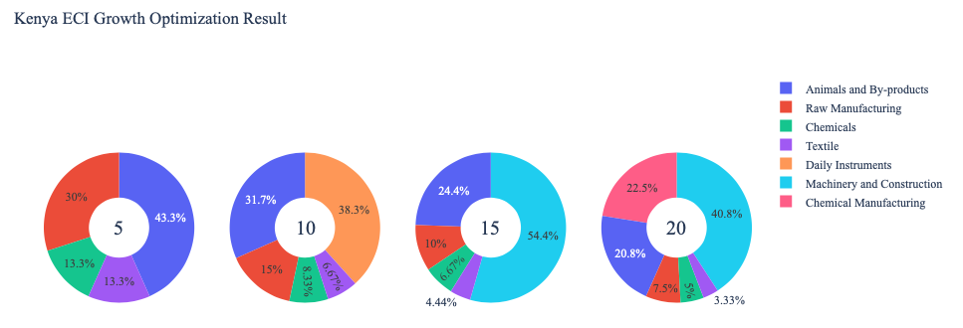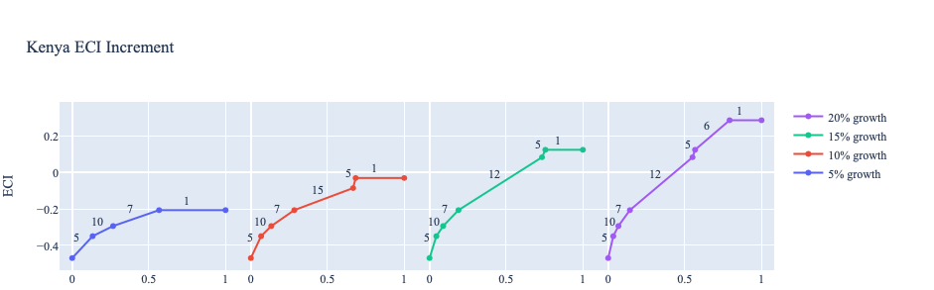
Figure 4b. Greedy-Based ECI Improvement Results of Kenya with Different Budgets (2018)

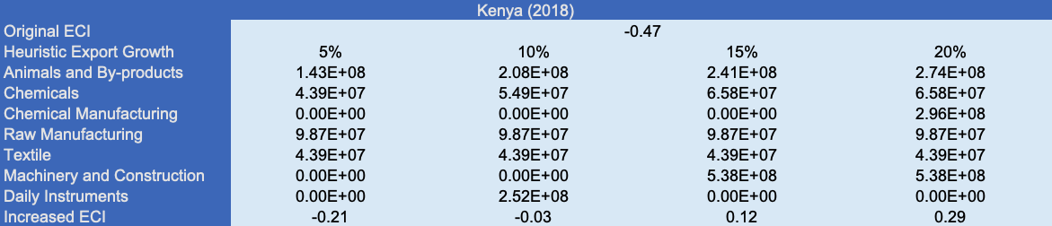
Table 8b. Portfolio of Kenya (2018)

To compare with the performance in 2013 and 2018, we also re-examine suggested strategies for 2022. For 2022, a 5 percent increase in export would emphasize Energy Drilling and Mining, followed by Energy Drilling and Mining, Wood Products, and High-complexity Products for 10, 15, and 20 percent export growth respectively. These strategies go in line with the suggested trajectories based on ECI. In all cases, Energy Drilling and Mining served as an important factor. This suggests a need for strategic investments in energy-related infrastructure. A more detailed numerical representation of the portfolio for Kenya is shown in Table 8c.
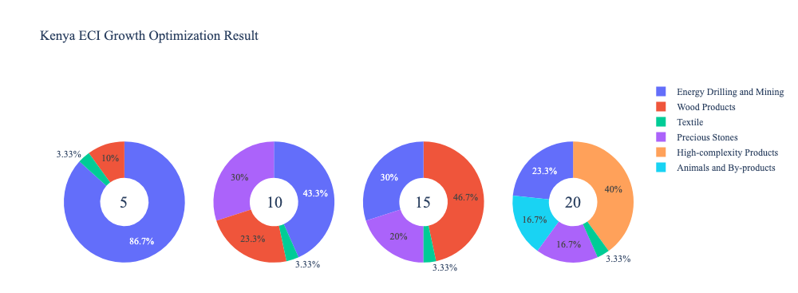
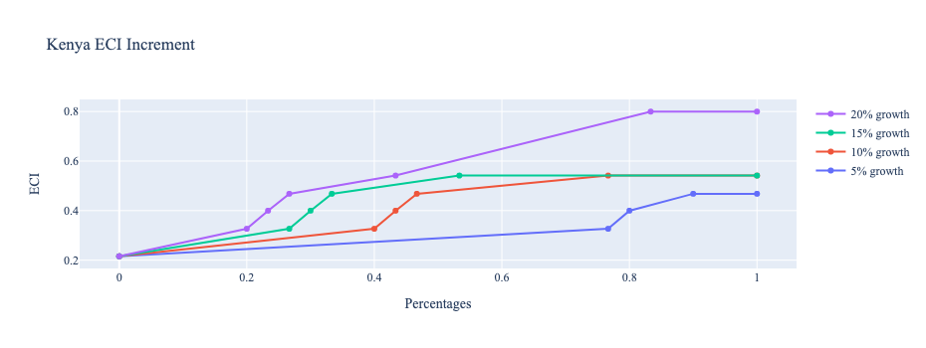
Figure 4c. Greedy-Based ECI Improvement Results of Kenya with Different Budgets (2022)

Kenya (2022)
Original ECI | 0.347
Heuristic Export Growth | 5% | 10% | 15% | 20%
Animals and By-products | 0.00E+00 | 0.00E+00 | 0.00E+00 | 2.30E+08
Energy Drilling and Mining | 4.99E+08 | 2.99E_08 | 3.11E+08 | 3.22E+08
Wood Products | 5.76E+07 | 1.61E+08 | 4.84E+08 | 0.00E+00
Textile | 1.92E+07 | 2.30E+07 | 3.45E+07 | 4.61E+07
Precious Stones | 0.00E+00 | 2.07E+07 | 2.07E+08 | 2.30E+08
High-complexity Products | 0.00E+00 | 0.00E+00 | 0.00E+00 | 5.53E+08
Increased ECI | 0.468 | 0.541 | 0.541 | 0.800
Table 8c. Portfolio of Kenya (2022)

4.3 Sensitivity Analysis and Contingency Strategy
In the following section, our broad aim is to understand how sensitive Kenya is to changes in export in various industries. While the Economic Complexity Index has been shown to contain valuable information about the economic strength/capacity of a country, little has been said as to the stability of the measure itself. We seek to uncover the main drivers of stability under a country's ECI score and better understand longer-term projections for ECI growth. Additionally, gaining an intuition on the industries that are bolstering an economy and the industries that offer the greatest return per unit of investment is best done through visualization of industry-specific sensitivity. To this end, we have developed two categories of sensitivity analysis.
ECI Sensitivity Graph
First, in order to assess the effect particular industries have on each respective country, we developed ECI Sensitivity graphs (Figure 5). We use the shocking methodology to increment or decrement an industry’s export level by a certain percentage and recalculate the ECI, all else being equal. While freezing the export dynamics of the rest of the world and enacting an instantaneous shock in export for a particular industry and country may not reflect real-life dynamics, what it does offer us is an understanding of a country’s level of dependency on an industry in the context of ECI. The shocking is done in small percentage increments in order to smooth out the resulting curve. Additionally, a recurring theme one will see is that for most industries, a breaking point occurs where the ECI either jumps upwards or downwards, creating a hockey stick shape rather than a linear trend. While the inflection point may not be accurate in the context of real life, comparing the various inflection points across industries can give us valuable insight.

Figure 5. Sample ECI Sensitivity Graph (2018)
The graphs are formulated as follows. There are six ECI Sensitivity graphs, two for each of the following years: 2022, 2018, and 2013. The first chart, Incremental ECI Sensitivity, shows positive shocking in which export numbers are shocked upwards per industry. The X-axis is in terms of percentage shock per current dollar value of export. The Y-axis is the recalculated ECI level post-shocking. The second chart, Decremental ECI Sensitivity, follows the same format except the X-axis represents negative shock. In other words, exports for each industry are decremented, and the ECI is accordingly recomputed.
SDV Sensitivity
Secondly, we analyze the sensitivity of the SDV to changes in export levels. The goal is to understand how export level changes for a particular industry can affect the marginal opportunity gain for other industries. We will be increasing or decreasing the absolute export level in two industries and observing the effects on the SDV.
When the opportunity gain of an industry is negative, the SDV sensitivity approximates how an over-development of the industry jeopardizes the economic structure of a country. When the opportunity gain of the industry is zero, the SDV sensitivity determines whether the further development of the industry shapes the country with a better economic structure and predicts how the SDV would change accordingly. Specifically, as we reduce the export of such an industry to 25% - 50% of its original value, a few other industries originally with negative opportunity gain could likely become profitable.
Similar to the ECI sensitivity graphs above, we will be shocking the export of two industries in small percentage increments. A new SDV, represented by a new column in the charts, is recorded only when a certain level of shock changes the structure of the SDV. In effect, we are incrementing or decrementing export levels of two industries until the marginal opportunity gain of any industry changes in category (positive, negative, or neutral). Below is an example of an SDV Sensitivity chart with Positive Shocking. Industries with positive marginal opportunity gain are colored blue, neutral is colored white, and negative is colored red.


Table 9. Sample Incremental SDV Sensitivity for High-Complexity Products (2018)

Contingency Plan
The Contingency Plan aims to present a set of solutions with respect to upheavals in different industries. Instead of compensating for the declining production directly, the best strategy is to develop those incipiently profitable industries. In this manner, we can derive a contingency strategy for countries to deal with possible abrupt declines of crucial industries. In some cases, the SDV remains unchanged even when a zero-opportunity-gain industry declines to 20% in terms of export. We can then conclude the industry is not indispensable to the country. As a clarification, the three consecutive N/As mean that the country doesn’t even need to respond to a collapse in the industry. Countries tend to have distinct solutions to the ups and downs of the same industry. To create the contingency strategy table, we decrease the export level for each industry in the country’s current production space by 60% respectively. The three highest-ranking industries in the new SDV are then returned.

Product Names | 0 | 1 | 2
Animal and By-products | Services and Utilities | Daily Instruments | Weapons
Vegetables, Fruits and Plants | Services and Utilities | Daily Instruments | Weapons
Food and Preparations | Services and Utilities | Daily Instruments | Weapons
Energy Drilling and Mining | Services and Utilities | Daily Instruments | Weapons
Chemicals | Services and Utilities | Daily Instruments | Weapons
Chemical Manufacturing | Services and Utilities | Daily Instruments | Weapons
Raw Manufacturing | Services and Utilities | Daily Instruments | Weapons
Wood Products | Services and Utilities | Daily Instruments | Weapons
Clothing and Accessories | Services and Utilities | Daily Instruments | Weapons
Textile | Services and Utilities | Daily Instruments | Weapons
Metals | Services and Utilities | Daily Instruments | Weapons
Machinery and Constructions | Services and Utilities | Daily Instruments | Weapons
Transportation | Services and Utilities | Raw Manufacturing | Daily Instruments
Weapons | Services and Utilities | Daily Instruments | Transportation
Daily Instruments | Services and Utilities | Weapons | Transportation
Precious Stones | Services and Utilities | Daily Instruments | Weapons
Daily Instruments | Services and Utilities | Daily Instruments | Weapons
Services and Utilities | Daily Instruments | Weapons | Transportation
Table 10. Sample Contingency Strategy (2018)

4.3 Sensitivity Analysis Results and Interpretation
We examine Kenya's ECI Decremental and Incremental Sensitivity Charts for 2022. An increase in Chemicals will lead to the highest change in ECI, followed by Chemical Manufacturing and Machinery and Construction. The strong sensitivity effect of manipulating the Chemical Manufacturing category remains consistent with previous years. For the negative shock cases, Vegetables, Fruits, and Plants becomes most impactful, a new trend across the data emerging from the previous years. The rest of the industries do not appear to have the same level of sensitivity.

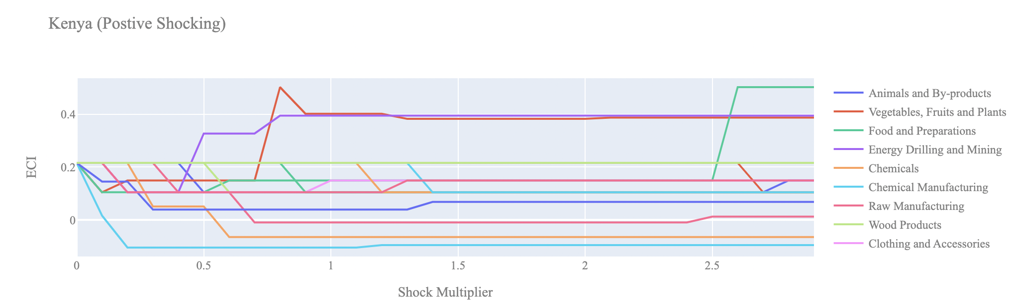

Figure 6a. Incremental ECI Sensitivity for Kenya (2022)

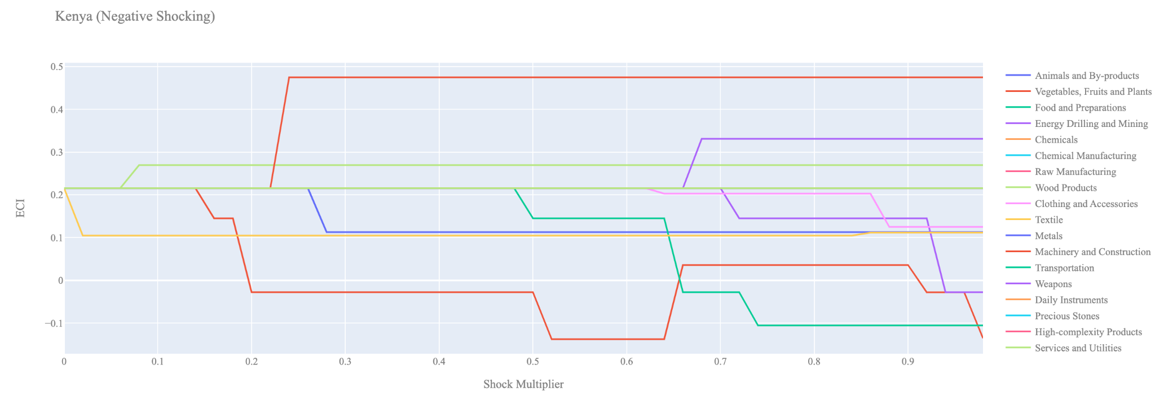
Figure 6b. Decremental ECI Sensitivity for Kenya (2022)

Below is Kenya’s 2018 ECI Sensitivity Charts. Firstly, in the positive chart, we notice immediately that increases in Raw Manufacturing and Chemical Manufacturing lead to increases in the ECI level. We also notice that increases in Animals & By-products and Vegetables, Fruits and Plants actually decrease the ECI score, implying that these are not worthwhile industries for Kenya to expand further into.

Next, we consider Kenya’s 2018 Negative Shock chart. We see that Kenya is highly sensitive to changes in export levels in Energy, Drilling & Mining, Weapons, and Chemical Manufacturing. That being said, decreases in the export of Weapons, and Chemical Manufacturing lead to large drops in ECI, whereas decreases in export of Energy, Drilling & Mining drastically increases ECI.

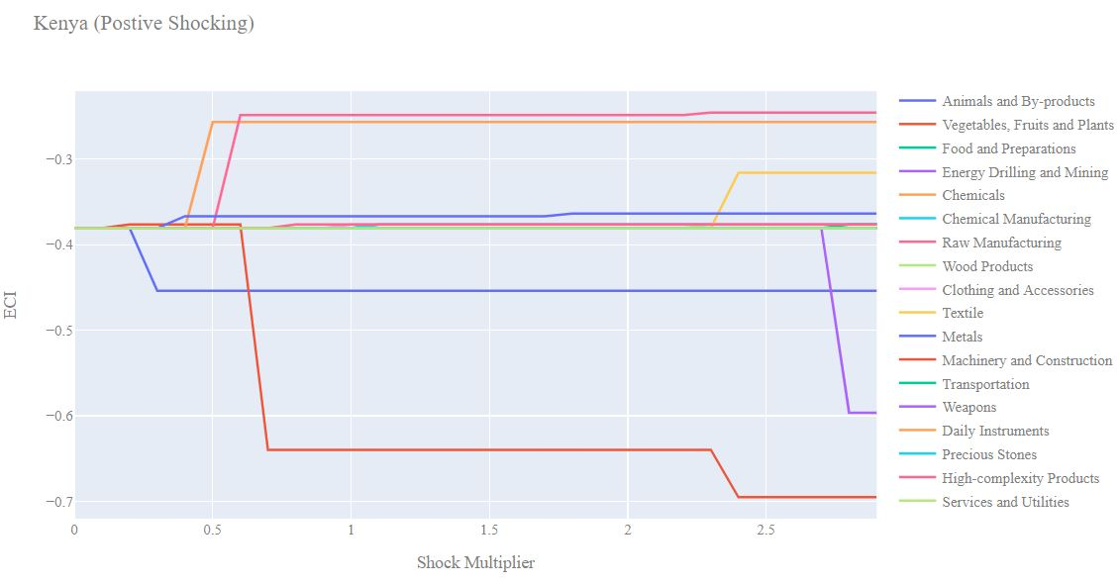
Figure 7a. Incremental ECI Sensitivity for Kenya (2018)

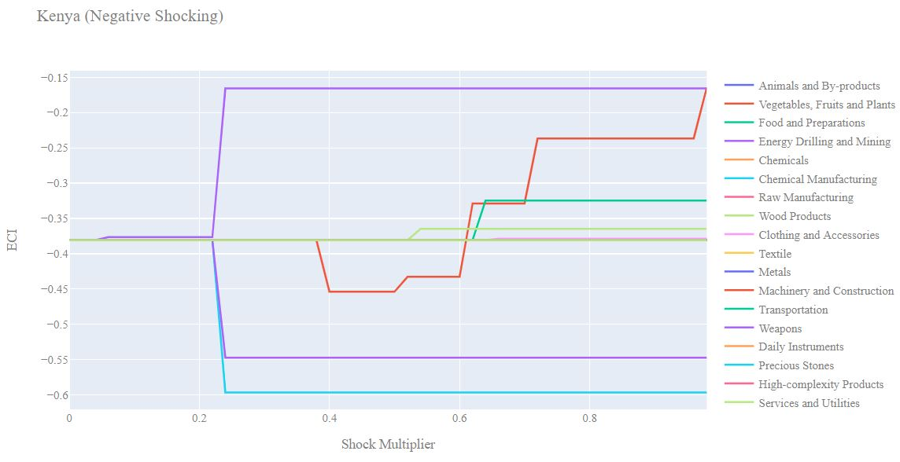
Figure 7b. Decremental ECI Sensitivity for Kenya (2018)

Next, we consider the 2013 ECI Sensitivity graphs. Firstly, we notice in the positive shocking case that the 2013 ECI sensitivity landscape is quite different from 2018. Increases in the export of Vegetables, Fruit & Plants, Energy, Drilling & Mining, Precious Stones, and High-complexity Products actually lead to downturns in Kenya’s ECI score.

In the negative shocking case, we see that it is most beneficial for Kenya to decrease its export of Animals and By-products since this leads to an immediate increase in the ECI score. The industries that Kenya’s ECI score seems to be dependent on include Chemical Manufacturing, Raw Manufacturing, and Metals.

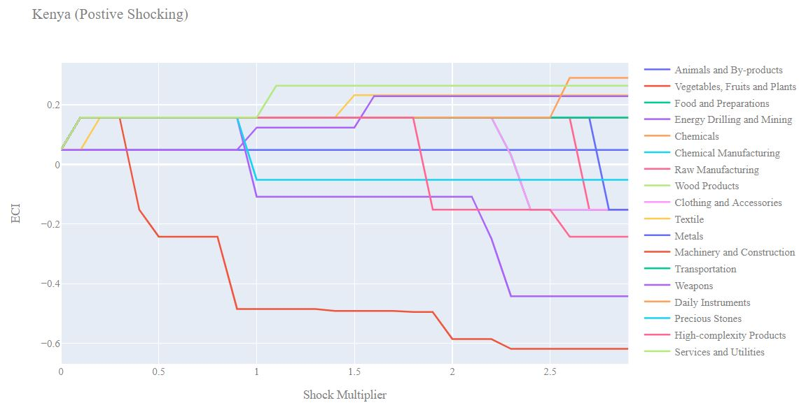
Figure 8a. Incremental ECI Sensitivity for Kenya (2013)

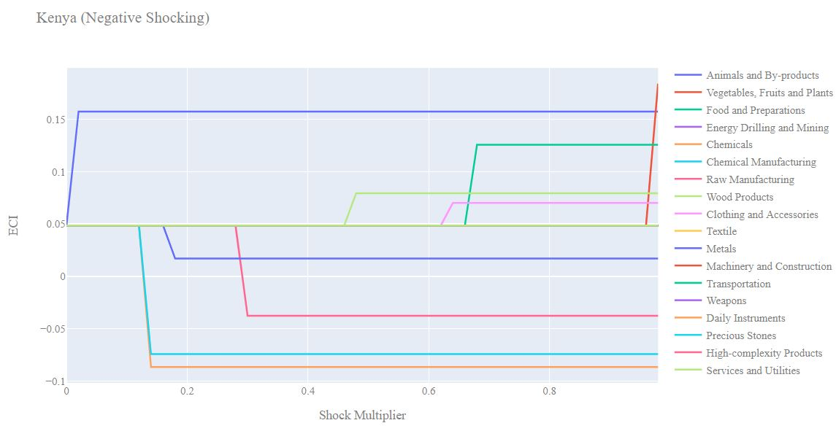
Figure 8b. Decremental ECI Sensitivity for Kenya (2013)

4.4 Contingency Strategy
Decreasing export of each industry in Kenya’s current production space by 60% respectively, we derive the contingency strategy shown below. Though such strategic choices might have been effective in helping Kenya navigate the economic challenges brought about by the 2020 COVID-19 pandemic, our examination of structural optimality in the subsequent section reveals that Kenya's industrial development strategy during the 2019-2022 period did not follow such a trajectory. This might be a contributing factor to Kenya's comparatively lower ECI by the end of this timeframe.

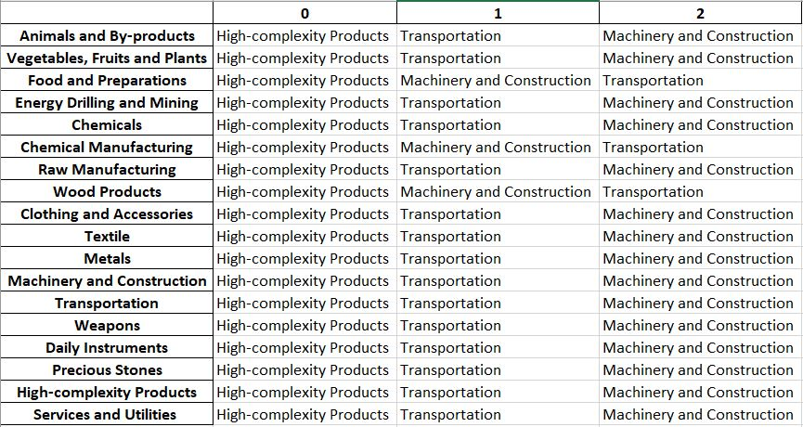
Table 13. Kenya’s Contingency Strategy (2018)

5. Macro-level Predictions

5.1 Structural Optimality Index
ECI sensitivity described in the section before has proven to be a significant factor in deciding the economic outcomes of countries. In order to quantitatively evaluate how effective our development strategies are and how deviations from the suggested developmental path will lead to suboptimal growth results, we define the measure – Structural Optimality Index (SOI) – on a country level as the Adjusted R-Square obtained from regressing the country’s realized industry development over the suggested development strategy. Both strategies are quantified in nature, with the realized development represented by increasing export in every major industry group and the suggested development strategy represented by the opportunity gains of developing the corresponding industry groups as calculated in previous sections. The adjusted R-square from the regression thus provides us with a quantified measure of how the development path adopted by the country has fitted with/differed from calculations on a complexity level.

After obtaining this measure for all countries in our database, we further regress countries’ five-year economic growth, which is defined as the percent increase in GDP (USD), over their SOI. Figure 6 illustrates the regression output, which shows a strong positive correlation between countries’ SOI and their five-year GDP growth, significant at the 1% level and achieving an adjusted R2 of 4.5%. In other words, the more a country develops as suggested by calculations at a complexity level, the better economic outcomes it achieves.

Table 14: OLS Regression Results
Dep. Variable: GDP | F-Statistic: 5.963
R²: 0.054 | Prob (F-Stat): 0.0163
Adj R²: 0.045 | No. Observations: 106


Figure 9. Regression of Five-Year GDP Growth over SOI (2013-2018)

5.2 SOI of Kenya and Its Implications
During the first examined period, Kenya, for instance, has a moderate level of structural optimality as compared with its developed peers. As the regression in Figure 10a suggests (the red curve represents export increase and the blue curve stands for opportunity gain of the corresponding industry), Kenya demonstrates a moderate level of correlation with the suggested developmental path, having an adjusted R-square of around 0.1606.

Kenya ranks in the top quartile among all countries in terms of SOI and has made a high rate of economic progress among its emerging peers from 2013 to 2018 with a 5-year GDP growth rate of 42.4%, which is consistent with the regression result in Figure 6. This is in direct contrast to developed economies such as Japan, where there is a moderate SOI of around -4.8% and a corresponding 5-year growth rate of 9.0%, ranking it as a slow-developing economy during the period. In sum, Kenya’s high rate of economic progress from 2013 to 2018 can be at least partially explained by a development strategy that demonstrates a strong level of alignment with our suggested developmental path. Specifically, Kenya invested heavily in the Energy & Drilling industry, as recommended.

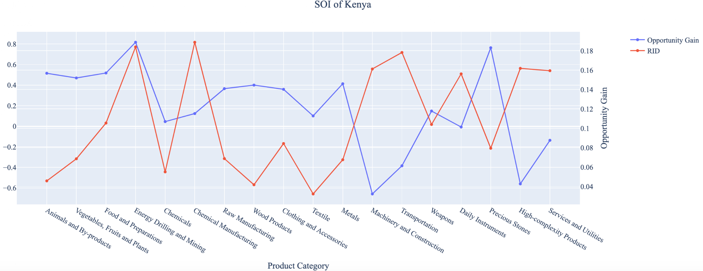
Figure 10a. SOI of Kenya (2013-2018)

For the 2019-2022 years, Kenya has a strong presence in the Chemical Manufacturing industry, but they seem to be overdeveloped when considering their lower opportunity gain relative to RID. It also could consider Precious Stones, and Energy Drilling and Mining to improve its growth.

Lower than before, its adjusted R-squared value of 0.012 now indicates a low correlation between the GDP growth and the implemented development path. Progress is slow on a global scale during this period, but Kenya demonstrates a greater ability to adjust to negative economic shocks by improving SOI and increasing GDP growth than it did between 2013 and 2018.

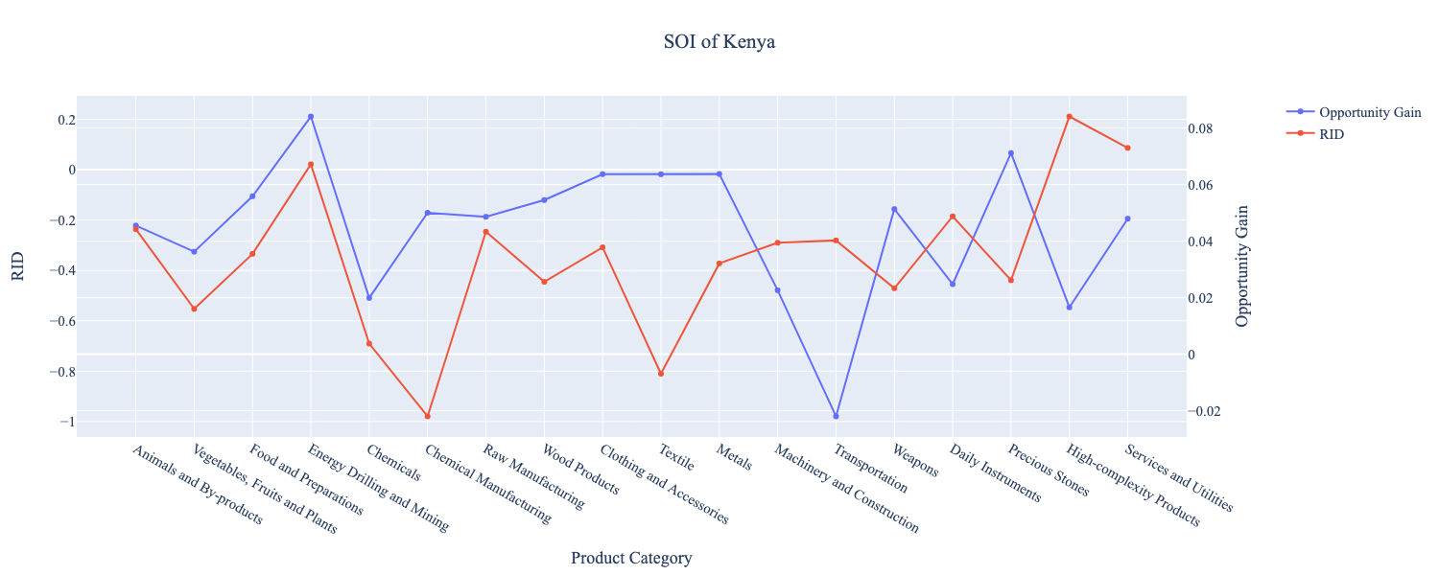
Figure 10b. SOI of Kenya (2019-2022)

6. Concluding Remarks

In conclusion, Kenya has demonstrated a moderate level of economic growth in terms of annual GDP increase during the period from 2013 to 2018, concurrent with an increase in economic complexity as compared with major developed economies. For 2019-2022, the growth in GDP has decreased alongside a large boost in ECI, in line with its comparable countries and higher than many developing economies in the world.

We believe that the mixed progress during the first period can be partially explained through the analysis of the economic and product complexity structure of Kenya on the industry group level. The product classification system we adopt allows us to measure the realized industry development for various industry groups and to observe that Kenya regressed in developing some of its industries during the period, while its developed counterparts and emerging economies around the globe adopted much more complex and progressive paths.

Based on our analysis of the opportunity gain and sensitivity analysis of major industry groups for 2013-2018, Kenya can further its gains by prioritizing Raw Manufacturing and Chemicals. We further note that Kenya has a balanced development strategy that indicates a moderate level (compared to other developing countries) of structural optimality on the complexity level, having an adjusted R-square of around 0.1606. Since a moderate exists between five-year GDP growth and the structural optimality index of an economy as we define and calculate, Kenya indeed has a suboptimal growth experience as compared with fast-growing economies both on a regional scale and on a global scale and has the potential to further its economic gains through industrial structure optimization as suggested in the paper.

During the second examined period from 2019 to 2022, Kenya performed much stronger than before and compared to other countries, particularly Nigeria. We infer that during the COVID-19 period, Kenya focused on developing lower complexity industries, in line with lower demand for these industries given the global economic downturn. We also note that Kenya has increased its investment in the sectors identified earlier, leading to a strong boost from the Energy Drilling and Mining industry, leaving some room for strategic improvement. It did invest in the industries which contributed the most to its advancements, such as Services and Utilities. The ECI suggests that greater growth could have been achieved through High-complexity Products, followed by Wood Products. The surprising growth also decreased the adjusted R-squared value to 0.012 in 2022 from 0.161 in 2018, demonstrating the pursued strategies contributed to the GDP. With the revised focus, Kenya has further potential to advance its economic growth to maintain its position among other countries to continue its ongoing economic expansion.

References

Hausmann, R., Hidalgo, C., Bustos, S., Coscia, M., Chung, S., Jimenez, J., Simoes, A. and Yıldırım, M. (2007). The Atlas of Economic Complexity. [online] Atlas.cid.harvard.edu. Available at: http://atlas.cid.harvard.edu/.

Balassa, B., “The Purchasing Power Parity Doctrine - A Reapprais- al,” Journal of Political Economy 72, 584-596 (1964).

Feenstra, R.; Lipsey, R.; Deng, H.; Ma, A. & Mo, H. “World Trade Flows: 1962-2000” NBER working paper 11040. National Bureau of Economic Research, Cambridge MA (2005).

United Nations Commodity Trade Statistics Database (http://comtrade.un.org/db/), accessed in August 2019.

The World Economic Forum, “The global competitiveness report,” (various years).

Barro, R. & Lee, J-W. “A New Data Set of Educational Attainment in the World, 1950-2010,” NBER Working Paper No. 1590 (2010).

Kaufmann, D. & Kraay, A. “Governance Indicators: Where Are We, Where Should We Be Going?” Policy Research Working Paper 4370. Washington, DC: World Bank (2008).

Hanushek, E.A. & Woessmann, L. “The Role of Cognitive Skills in Economic Development,” Journal of Economic Literature 46(3), 607- 668 (2008).

